EPEC-O
Education in Palliative and End-of-life Care - Oncology

Participant’s Handbook

Module 1
Comprehensive Assessment
Emanuel LL, Ferris FD, von Gunten CF, Von Roenn J.
EPEC-O: Education in Palliative and End-of-life Care for Oncology.
© The EPEC Project,™ Chicago, IL, 2005
ISBN: 0-9714180-9-8
Permission to reproduce EPEC-O curriculum materials is granted for non-commercial educational purposes only, provided that the above attribution statement and copyright are displayed. Commercial groups hosting not-for-profit programs must avoid use of EPEC-O materials with products, images or logos from the commercial entity.
The EPEC Project™ was created with the support of the American Medical Association and the Robert Wood Johnson Foundation. The EPEC-O curriculum is produced by The EPEC Project™ with major funding provided by the National Cancer Institute, with supplemental funding provided by the Lance Armstrong Foundation. The American Society of Clinical Oncology partners with the EPEC-O Project in dissemination of the EPEC-O Curriculum. Acknowledgment and appreciation are extended to Northwestern University’s Feinberg School of Medicine, which houses The EPEC Project.
Special thanks to the EPEC-O Team, the EPEC-O Expert Panel, and all other contributors.
Accreditation Statement
The Northwestern University Feinberg School of Medicine is accredited by the Accreditation Council for Continuing Medical Education to provide continuing medical education for physicians.
Visit www.epec.net to order EPEC materials, access On-line Distance Learning, or for further information.
Contact EPEC by E-mail at info@epec.net, or

The EPEC Project™
750 N. Lake Shore Drive, Suite 601
Chicago, IL 60611
USA
Phone: +1 (312) 503-EPEC (3732)
Fax: +1 (312) 503-4355

Abstract
Comprehensive cancer care aims to treat both the underlying disease process(es) and the experience of living with cancer. Patients suffer as whole persons: persons with relationships to others, a past, and an anticipated future. Suffering can be the result of manifestations of the disease process, predicaments created by it, or the process or therapies used to provide care.
A comprehensive assessment sheds light on the fixed characteristics of the patient, the management of the underlying disease process, any physical, psychological, social, spiritual, practical, end-of-life, loss/grief issues that are a concern to the patient or family, and the critical steps in the process of providing care, including information sharing, decision-making, care planning and delivery, and confirmation of the quality of the care.
This very broad assessment is manageable if the functional inquiry starts by using screening questions to highlight domains of issues that are of concern. Then, based on the answers, the clinician performs a more in-depth evaluation of specific issues. While it may initially seem to be an overwhelming task, to keep within allotted visit schedules, a full evaluation can be complete over several routine visits. Other members of the cancer care team can also assist with multiple components of the detailed assessment.
Comprehensive assessments not only start out the therapeutic relationship; they recur through the course of the illness. The focus shifts depending on the illness stage, individual needs, and changing goals of care. Even a physician who is familiar with a patient should expect to conduct periodic assessments of all domains of potential suffering from diagnosis until the end of the therapeutic relationship.

Key words
Anticipatory planning, communities, confidentiality, culture, decision-making capacity, disease history, economic burdens, experience of illness, family, framework, healthcare systems, hopes, information sharing, interdisciplinary assessment, meaning, modifiable dimensions, outcomes, pastor, personhood, physical symptoms, practical needs, psychological symptoms, social worker, social circumstances, spiritual needs, suffering, whole patient, anticipatory grief, adjustment.

Objectives
After studying this module, oncologists and other members of the cancer care team will be able to:
- Describe conceptions of suffering.
- Describe a framework to guide assessment of the multiple issues that frequently cause patients and families suffering and the process of providing care.
- Use a validated screening tool, ‘NEST,’ to facilitate an initial screening assessment.
- Carry out a detailed assessment of active issues.

Clinical case on trigger tape
K. M. is a woman in her 50s with adenocarcinoma of unknown origin, initially found in her lung and excised as a primary, and then presenting in her axillary nodes and behaving more like breast cancer. She returns for a routine visit, after surgery and chemotherapy, with an apparent remission. A medical student greets her and asks to take a comprehensive assessment prior to the attending physician’s arrival.

Introduction
Assessment, the process of evaluating a specific issue to gather data, is a core skill of all clinicians, particularly oncologists.
As part of comprehensive cancer care that incorporates palliative care, in addition to reviewing patient characteristics and managing the cancer, a thorough assessment reviews the multiple issues that cause patients and families suffering, and the process of providing care. Not only is the goal of comprehensive cancer care to manage the underlying cancer and all of its associated comorbidities, it also aims to prevent and relieve suffering and promote quality of living (and dying) for the patient and her/his family, ie, those close in knowledge, care, and affection.
The public imagines that medical professionals study the issue of suffering in medical school. Indeed, they expect us to be experts at the relief of suffering. The public would be shocked to learn that this subject doesn’t get much attention in medical training, including the training of oncologists.
Because the oncologist is the member of the cancer care team who coordinates and directs care, it is important that s/he know how to organize these concepts into a framework that can be used to guide the assessment of each dimension of suffering and each step in the process of providing care.
However, in a busy clinic, it is unlikely that the oncologist alone will have time to complete a comprehensive assessment. Other members of the cancer care team, eg, nurses, social workers, chaplains, palliative care consultants, will be relied on to conduct important components of the detailed assessment.
The successful integration of information gathered by several different team members takes effort and coordination. Interdisciplinary team case conferences, eg, tumor boards, provide an excellent opportunity to synthesize the data that has been collected, discuss possible therapies and plan the process to facilitate decision-making with the patient and family.
An assessment can also be a therapeutic tool. Besides providing information, each assessment offers an opportunity for discussion with the patient, proxy, and/or family about the context of patient’s disease, prognosis, the multiple issues that are causing suffering, and the process of providing care. It is a time to emphasize the need for advance planning and personal preparation, particularly when the oncologist anticipates that the patient will deteriorate in the not-too-distant future. In most instances, a careful functional inquiry coupled with active listening, during which the clinician reflects back her/his understanding of the conversation, can reassure the patient and family that they have been heard and minimize the risk of conflict. By offering information and practical advice, by introducing sources of support, through attention to details and enough time ‘to be heard,’ a comprehensive assessment will give the patient and family a chance to build trust and a therapeutic relationship, and see the humanity of the physician.
All comprehensive assessments include a detailed history including a review of the effect of medications and any adverse events or allergies, a physical examination, and laboratory and radiological investigations appropriate for the patient’s situation and goals of care. This module will focus on the essential elements of assessment for each major dimension of patient experience with their illness and the health care system. To keep the focus on palliative care, it is assumed that the oncologist is already highly skilled in taking a complete disease and treatment history and conducting a full physical examination.

Conceptions of suffering
What does it mean to suffer? Everyone of us will have a very personal sense of what brings meaning and value to our lives. We will also have a very personal sense of what causes suffering. Your perspective may be very different from someone else’s. You will not know what they are hoping for unless you ask.
As a medical profession, and as part of a healthcare system, each one of us must have a conceptual framework within which to work, study, and teach if we are to have a hope of relieving suffering. This is similar to other aspects of medicine—for each disease, each condition for which human beings seek assistance from the healthcare professions, there is a conceptual framework to investigate, understand, and intervene.
In an attempt to understand suffering in a way that would permit further study and understanding and inform clinical care, Cassell outlined a conceptual framework for suffering.Error: Reference source not found He pointed out that “bodies do not suffer, only persons do.” Persons are unique and do not experience a disease in the same way. Persons suffer when their personhood is threatened. Elements of what it means to be a person include having a past, a present, an anticipated future, a private life, a role, and a transcendent dimension.
Brody has built on the concept that personhood requires a past, present, and future by noting that human lives are, in a sense, stories. Our story is our sense of self, and as we face a diagnosis like cancer, our story takes an unexpected turn. If death occurs, the story ends. In this conceptual framework, our story transforms into our legacy. So often, when the patient comes to a physician, the emotional subtext of the patient’s complaint can be heard as, “Doctor, my story is broken. Can you fix it?” Much suffering by patients facing cancer can be understood in this perspective. The future looks different from before, and the present is consumed with new physical concerns. The patient’s private life is challenged by unanticipated and unwelcome transitions. The transcendent dimension may take on a new meaning.
Suffering is a challenge to meaning. Facing cancer may challenge our usual sources of meaning. Loss of meaning is a form of suffering. Meaning usually must be found in new ways when a serious illness intervenes. As you consider what you would list as the things that give you the most meaning and value in your life, think about how the prospect of cancer might affect those. Byock has described the nature of opportunity brought by suffering and facing life-threatening illness.
These same aspects apply to a child who has cancer. In addition to the suffering of the child who is seriously ill, the parents and siblings suffer as they face the illness of this child, and their shared sense of the future.
However, the experience of illness and suffering is not unique to each individual. In listening to patients with advanced cancer describe their needs and expectations for care, Cicely Saunders, founder of the modern hospice movement, conceptualized suffering as having four elements. She termed it ‘total pain’ and identified the elements of physical, psychological (emotional), social (including practical), and spiritual pain.

The broad perspective
All of these conceptions have one thing in common; they take a very broad perspective from which to view human existence. As oncologists, it is important that we have a comprehensive framework from which to work if we are to relieve suffering and enhance quality of life. Well-intentioned efforts that are too narrow in scope will miss the target. For example, pursuit of ‘curing the cancer’ may miss achievement of patient and family well-being. A narrow focus on physical pain can miss the patient who is depressed, or doesn’t have the money for the pain medicines, or is afraid that the pain means that she is going to die. Yet, all of these aspects of human experience will influence the experience of pain. Similarly, a patient whose spiritual foundation is not challenged is less likely to complain about physical symptoms, while failure to address the spiritual dimension in a patient who is spiritually distressed may distort the physical dimension. As another example, a patient who feels abandoned by family, community, or medical professionals may express his or her suffering by emphasizing a physical complaint, or by giving up hope. While each aspect of human existence is an integral part of who we are, undue focus on any one aspect may be detrimental, eg, undue focus on a patient’s social disconnection may distract a clinician from attending to physical needs.

Dimensions of illness, bereavement and cancer care
Based on these conceptions of suffering and a commitment to the broad perspective of human existence, it is helpful to have a framework that is rooted in the experience of the patient’s and family’s illness and bereavement and their experience of the health care delivery system. This framework can be thought of in 3 categories: fixed characteristics, modifiable dimensions, and healthcare interventions that are part of the process of providing care and their associated outcomes. Similar frameworks have been developed by several investigators based on empirical findings from patients’ perspectives, yielding some external validity for the overall construct.,

Fixed characteristics
Issues that arise as patients and family face cancer, goals of care, and expectations about how therapeutic relationships are handled differently depending on each person’s background and experience of life, ie, age, gender, race, ethnicity, culture, religion, socioeconomic class, etc.
As the United States becomes more ethnically diverse, physicians are increasingly likely to encounter patients whose world views and health beliefs differ from their own. If these differences are not recognized, they can impede communication and harm the therapeutic relationship.
If oncologists and cancer care teams are to provide care “in a manner that is respectful of the patient's and family's personal, cultural, and religious values, beliefs, and practices…,” it will be important to know basic information about the patient and her or his family from the outset.

Culture
Culture is a societal group’s learned, repetitive, characteristic way of behaving, feeling, thinking, and being. It is transmitted from one generation to another through language, role modeling, child enculturation, and other means.
Since the way in which people perceive palliative care can be significantly influenced by their cultural values and beliefs, cultural competence among physicians is essential. Cultural competence is viewed by many professional organizations as a continuum, and many have developed guidelines for cultural competency training and cross-cultural care giving practice. One of the most widely used conceptual schema was first developed for mental health practice and has wide applicability. It focuses on an organization’s overall cultural competence.
Organizations may be perceived as progressing from negligence to inclusion, as follows: Cultural Destructiveness reflects behaviors harmful to certain cultural groups. Cultural Incapacity occurs when there is not capacity to help members of diverse cultural groups. Cultural Blindness assumes that what works for members of the dominant culture will work for everyone. Cultural Pre-competence recognizes limitations exist and seeks improvement in working with diverse cultural groups. Cultural Competence entails accepting and respecting cultural differences and assessing and seeking to expand knowledge base to ensure an inclusive relationship centered on patients. Cultural Proficiency entails promoting genuine cross-cultural initiatives in the relationship. Resources for promoting cultural competence and proficiency are expanded on in the Resources section of this module.
Culture has been shown to be a strong determinant in attitudes toward health, illness, and dying. However, it is important to remember that people are individuals. The best way to understand another person's culture is to listen carefully to her or his values and beliefs. Do not assume that each individuals values, beliefs and practices track with cultural norms. Through respectful inquiry, oncologists and members of the cancer care team can quickly learn about each individual patient’s background and specific cultural issues.
Respect can be conveyed by erring on the formal side of normal interactions, at least to begin with. It is important to remember that our current-day norms in the United States of informality, eg, addressing people by first names, are in the minority among cultural approaches. If questions are respectfully posed, they will rarely be offensive.
It is always best to use interpreters when language barriers exist; using family members is fraught with difficulty. If there is a translator, you can also learn from him or her if someone is available and knowledgeable in the relevant group’s context for living.
Further cultural considerations are treated in various modules, including issues of information, truth telling and involvement of translators (see EPEC-O Module 7: Communicating Effectively and Module 8: Clarifying Diagnosis and Prognosis), and maintaining reasonable hope (see EPEC-O Module 9: Negotiating Goals of Care).

Modifiable dimensions
In addition to the cancer, there are often aspects of a patient’s experience of illness and bereavement that are more modifiable than may be apparent initially. Physical symptoms, psychological issues, social relationships and support, economic demands, spiritual and existential beliefs, hopes, expectations, practical and caregiving needs, preparedness for death and the grief that comes with real and anticipated losses can all change with time and effort. If left untreated, they may also impact the modifiability of the patient’s cancer.
These issues can be divided into 8 core domains (see Figure 1 for an overview and Appendix 1 for a more detailed listing of these issues that can be used to guide a functional inquiry).

Health system interventions
Technical interventions have been the main focus of much of cancer care. In this larger perspective it is clear that the delivery of technical interventions is just one of six steps in the process of providing comprehensive cancer care (see Figure 2 for an overview and Appendix 2 for a more detailed listing of the steps in the process of providing care that can be used to guide a functional inquiry).

Figure 1: Domains of issues during illness and bereavement
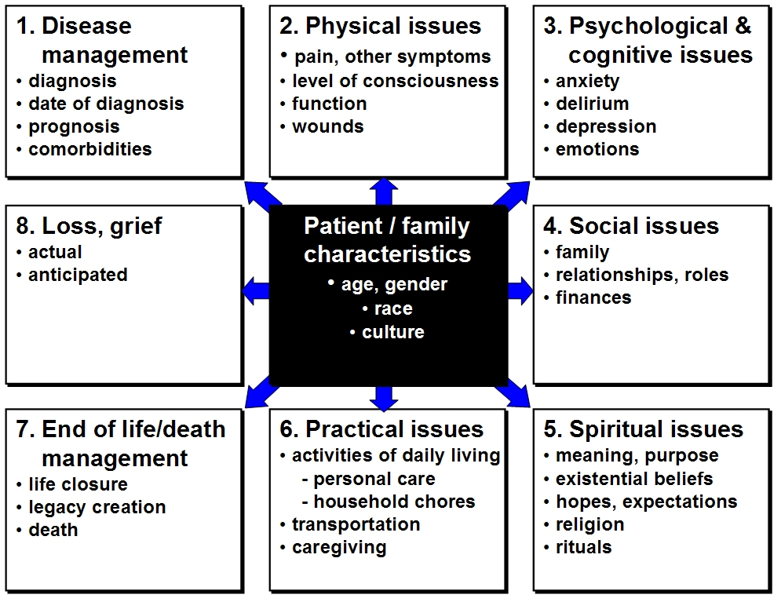

Figure 2: Essential steps in the process of providing care
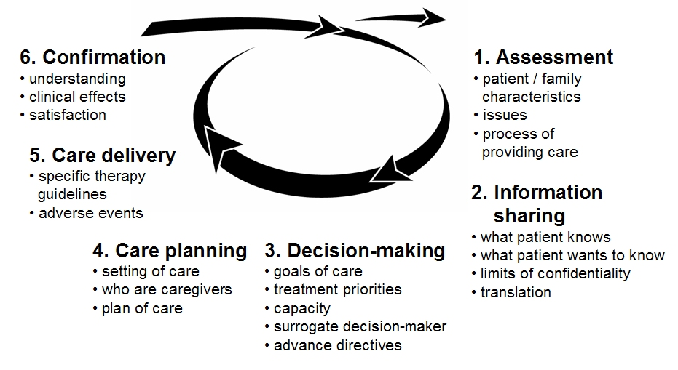

Efficient assessment
The dimensions of illness, bereavement and cancer care presented in Figures 1 and 2 and elaborated on in Appendix 1 and 2 provide a simple framework to guide assessment. Their routine use will ensure that the oncologist and other members of the cancer care team don’t miss asking about issues that may be of concern to the patient and family.
During the initial portion of your first assessment of a new patient, find out some basic facts about the person, and how to relate to her/him in a respectful fashion. This can be accomplished with a simple inquiry about how the patient would like to be addressed or greeted. For some, a first name is comfortable or even comforting, but for others it is disrespectful. For some, a hand shake is affirming, but for others it is forbidden to touch the opposite gender.
Then, to make the assessment process more efficient, divide it into 2 phases – an initial screening to identify issues of concern followed by a detailed evaluation of all active issues.

Initial screening
During the initial screening, start by asking open-ended questions about the patient, her/his overall health and understanding of the situation. Then, ask a series of validated screening questions that efficiently assess each of the major dimensions of the issues that frequently cause suffering and the process of providing care. One such validated screening tool is ‘NEST.’ Others, such as RAI-PC, are also available.
Once a need is detected, more specific evaluation questions can follow. As demonstrated in the trigger tape, a whole-person assessment can be completed comfortably within the usual 15 minute office visit if the physician is practiced in its use.

Screening with NEST
‘NEST’ utilizes a series of questions selected for their sensitivity to detect needs that are of concern to the patient. These have been grouped into four dimensions to generate the pneumonic ‘NEST’: 1) Needs in the social domain; 2) Existential matters; 3) Symptom management needs; and 4) Therapeutic relationship matters.
To allow for a deft approach to sensitive concerns, ask the ‘NEST’ questions in reverse order. Start by orienting yourself to the patient’s cultural context. Leave inquiry into financial matters to the end. Memorize the screening questions from each area. With practice they will flow smoothly in a conversational manner.
Table 1: NEST screening questions
NEST groupings  (reversed) | Screening questions | Domains
To inquire about Therapeutic relationships: | - How much do you feel your doctors and nurses understand how to relate to you with respect? | Patient/family characteristics
 | - How clear is the information from the medical team about what to expect regarding your illness? | Information sharing
 | - 3. How much do you feel that the medical care you are getting fits with your goals? | Decision-making
To inquire about Symptoms: | - How much do you suffer from physical symptoms such as pain, shortness of breath, fatigue, bowel or urination problems? | Physical
 | - In your mind, how often do you feel confused or anxious or depressed? | Psychological
To inquire about Existential matters: | - How much does religious belief or your spiritual life contribute to your sense of well-being? | Spiritual
 | - How much does this illness seem distressingly senseless and meaningless? | Spiritual
 | - How much do have you settled relationship with the people close to you? | Spiritual
 | - Since your illness, how much do you live life with a special sense of purpose | Spiritual
To inquire about social Needs | - How much trouble do you have getting access to the medical care you need? | Practical
 | - How much help do you need with caregiving – things like getting meals or getting to the doctor? | Practical
 | - How often is there someone to confide in or feel close to? | Social
 | - How much of a financial hardship is your illness for you or your family? | Social

Detailed assessment
If the response to any of these questions suggests that there is a concern, then use more specific questions to explore the details. Depending on the extent of needs, their severity, urgency, and priority, evaluation may proceed directly or be postponed for another visit.
Detailed assessment strategies for many of the common issues that patients and families living with cancer face and the process of providing care are integrated throughout EPEC-O in the respective modules. Whenever possible use one of the scales in Figure 3 to quantify the severity of the symptom.
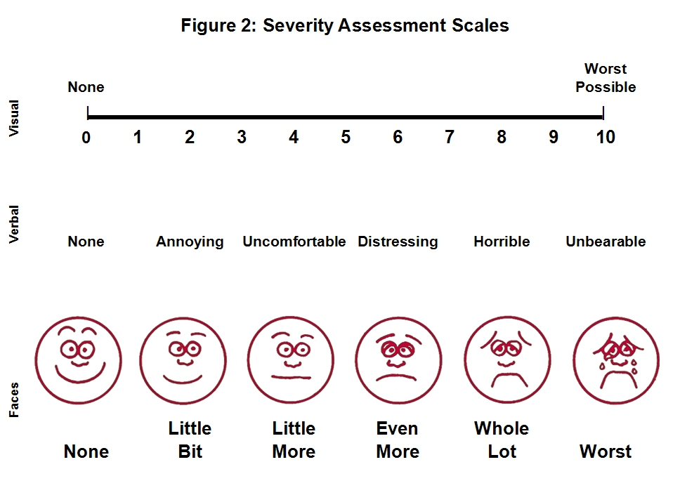
Figure 3: Severity assessment scales

Note: The Faces scale is adapted from the Wong-Baker FACES Pain Rating Scale.
Additional non-validated questions that may be useful to assess content areas not addressed in other EPEC-O modules are included in Appendix 3.
If there seems to be ‘no issue’ within a given dimension, that area can probably be considered ‘free of need’ and not evaluated further.
As part of the detailed assessment don’t forget to ask about past experiences with medications, any adverse events and allergies.
Before you finish, be sure to document your findings carefully.

Physical examination and tests
After your functional inquiry, conduct a physical examination. Depending on whether the encounter is for an initial comprehensive assessment or a focused evaluation, hold the physical exam until the full verbal portion of the comprehensive assessment has been completed. A physical examination not only adds to the history and provides baseline clinical information, it also establishes a relationship that includes therapeutic touch.
Occasionally, laboratory and radiological investigations are helpful. Before ordering any tests, decide with the patient and family how the result will change the plan of care, or not. In a few instances, it will also be valuable to know if there is disease stability or progression even when no therapeutic intervention is planned.

Summary
Patients and families have a multidimensional experience of their illness and the process used to provide them with care. To effectively manage all of the issues that cause patients and families suffering, oncologists and other members of the cancer care team must first be able to identify, assess, and understand them.
To conduct a comprehensive assessment efficiently, use a framework to guide functional inquiry (see Figures 1 and 2, and Appendices 1–2). To ascertain whether frequently occurring dimensions of the cancer experience are concerns, start by asking 13 screen questions from ‘NEST.’ Then, conduct a more comprehensive for each of the issues where concerns or needs are identified. Detailed assessment strategies, including sample questions to ask, findings to look for on physical examination, and possible laboratory and radiological investigations are available in each of the EPEC-O modules. Additional non-validated questions that may be helpful for topics not included elsewhere in EPEC-O are in Appendix 3.
A whole-patient assessment sets the stage for the comprehensive cancer care team to address all of the patient’s and family’s sources of suffering. Use it periodically to screen for issues that require a detailed reassessment. Based on your findings and the patient’s goals of care, revise the plan of care appropriately.
By comparing serial assessments, members of the cancer care team will be able to determine the outcomes of their therapeutic interventions.

Key take-home points
- Patients’ suffering has a context; consider patients and families together.
- Bodies do not suffer, only persons do. Personhood means having a past, present, and future. Suffering is a challenge to meaning. Loss of meaning is a form of suffering.
- Elements in the broad conceptualization of comprehensive cancer care can be thought of in 3 categories: fixed elements, modifiable elements, health care interventions and their associated outcomes.
- The biggest need in changing the system of care is timely application of knowledge that is already available.
- Conceptual frameworks, approaches for investigating and understanding suffering, and approaches for intervention to relive suffering have been neglected in the training of physicians.
- Whenever possible, quantify the severity of an issue.
- Minimize the burden of laboratory and radiological investigations. Only order tests when the results will have a specific use.

Resources
American Board of Internal Medicine. Caring for the Dying: Identification and Promotion of Physician Competency. Philadelphia, PA: American Board of Internal Medicine; 1996:12-18.
Field MJ, Cassel CK, eds. Approaching Death: Improving Care at the End of Life. Washington, DC: National Academy Press; 1997:73-81.
Ingham J, Portenoy RK. The measurement of pain and other symptoms. In: Doyle D, Hanks GWC, MacDonald N, eds. Oxford Textbook of Palliative Medicine. 2nd ed. Oxford, England: Oxford University Press; 1998:203-219.
Jacox A, Carr DB, Payne R, et al. Management of Cancer Pain. Clinical practice guideline No. 9. AHCPR Publication No. 94-0592. Rockville, MD: Agency for Health Care Policy and Research, US Department of Health and Human Services, Public Health Service; 1994:24-28.
Lo B. Ruston D. Kates LW. Arnold RM. Cohen CB. Faber-Langendoen K. Pantilat SZ. Puchalski CM. Quill TR. Rabow MW. Schreiber S. Sulmasy DP. Tulsky JA. Working Group on Religious and Spiritual Issues at the End of Life. Discussing religious and spiritual issues at the end of life: a practical guide for physicians. JAMA. 287(6):749-54, 2002 Feb 13Portenoy RK. Contemporary Diagnosis and Management of Pain in Oncologic and AIDS Patients. Newton, PA: Handbooks in Health Care Co; 1997:14-43.
Storey P, Knight CF. Unipac 2: Alleviating Psychological and Spiritual Pain in the Terminally Ill. Reston, VA: American Academy of Hospice and Palliative Medicine; 1997:23-28.
Storey P, Knight CF. Unipac 3: Assessment and Treatment of Pain in the Terminally Ill. Reston, VA: American Academy of Hospice and Palliative Medicine; 1997:7-18.
Vachon MLS. The emotional problems of the patient. In: Doyle D, Hanks GWC, MacDonald N, eds. Oxford Textbook of Palliative Medicine. 2nd ed. Oxford, England: Oxford University Press; 1998:882-907.
Weissman A. Coping With Cancer. New York: McGraw-Hill; 1979.
Weissman DE. Consultation in palliative medicine. Arch Intern Med. 1997;157:733-737.
Wolfe J., Grier H. E., Klar N., Levin S. B., Ellenbogen J. M., Salem-Schatz S., Emanuel E. J., Weeks J. C. Symptoms and Suffering at the End of Life in Children with Cancer. N Engl J Med. 2000; 342:326-333.
Emanuel LL. Alpert HR. Emanuel EE. Concise screening questions for clinical assessments of terminal care: the needs near the end-of-life care screening tool. Journal of Palliative Medicine. 2001;4(4):465-474.

Appendix 1: Domains & issues of illness and bereavement
Patients and families face multiple issues during illness and bereavement that cause suffering. These issues can be grouped into 8 domains. The most common issues are listed below.
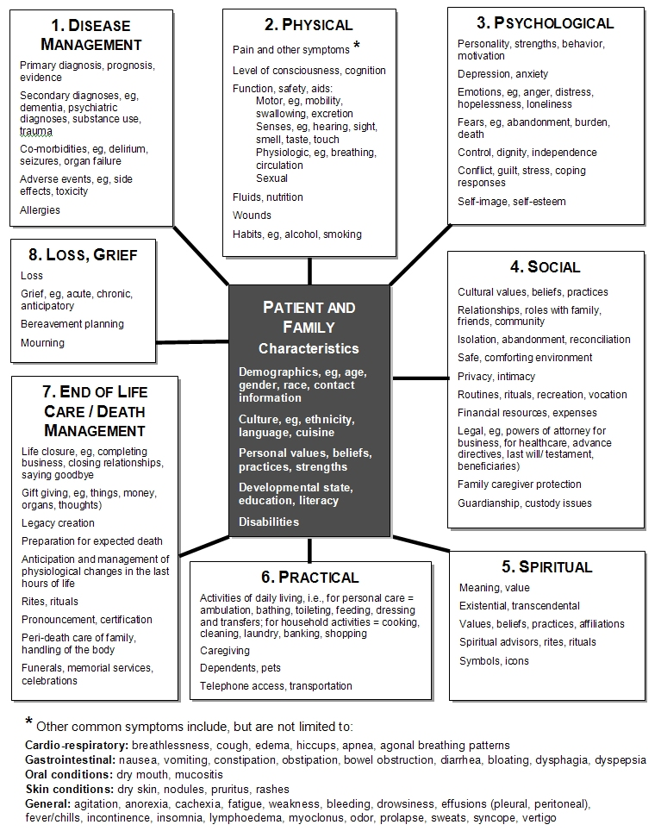

Appendix 2: Process of providing care
During each therapeutic encounter, the process for providing care involves six essential and several basic steps that guide the interaction between caregivers, and the patient and family. While these steps do not need to occur in any specific order, each one must be completed during each encounter. The most common steps are listed below.
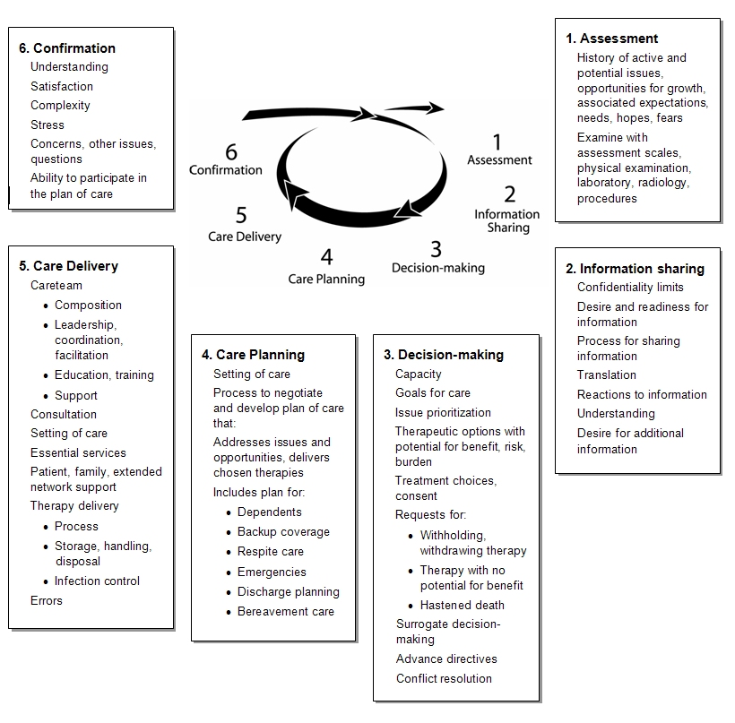

Appendix 3: Additional detailed assessment questions
In addition to the detailed assessments included in each of the modules of EPEC-O, oncologists may find the following non-validated questions to be useful during a detailed assessment.

Physical issues
Assess both motor and sensory functions.
- What is the patient’s performance status?
- Can the patient move around?
- Can the patient see or hear well enough?
- Is he or she safe?
- How are the physical aspects of relationships including sexual function?

Psychological issues
- How is the patient responding to the fact of being ill?
Consider naming some common responses, such as anger, grief, instability, and tranquility.

Social issues
Ask about family and what arrangements have been made.

Spiritual issues
This assessment phase includes understanding the patient’s:
Individual form of spirituality. How does the patient’s spirituality offer a sense of well-being and coping resources to him or her?
- When you are looking for spiritual comfort, what do you do?
If the patient seems hesitant, you can add:
- Some people listen to music, others pray or do something else; what helps you?
To find out if there is a community component to the patient’s spiritual life it can be simplest to ask:
- Do you have a community that you share your spiritual side with? Or: What role does religion play in your life?
Existential distress. How much does the cancer seem senseless and meaningless; how much does the patient feel settled in regards to his or her diagnosis and prognosis and the impact of that on personally important relationships? Be alert to the possibility of a spiritual crisis.
To gain insight into a patient’s spiritual orientation, a preamble can be helpful: ‘This illness seems to be especially distressing now. Then go on to ask a direct question such as: Do you sometimes feel abandoned or judged?’
- How do you understand the meaning of your illness?
- How much distress is it causing?
- Is it impacting any of your important relationships?
Purpose. Does the patient have a sense of purpose in life that is fitting with the patient’s prognosis and the illness’ limitations?
- How have you made sense of what’s happening to you?
- Do you feel that you have a sense of purpose in life that you can pursue, even with [having had] cancer?
A key question, whether for survivors or the terminally ill, may be:
- Do you feel settled in regards to your diagnosis and prognosis?
Unresolved issues
- Is there something that you would like to do before you get too sick?
- I think your child could manage a few half-days in school each week. Do you think that would help him?
- As you look back on your life, what has given your life the most meaning?
- For those with a poor prognosis who are aware of the fact, examples might be:
- Many people have old differences they would like to settle before they die. Is there anyone you want to be able to communicate with before you die?
- Many people have places or people they would like to visit. Do you?
- Some have a piece of work they would like to finish. Do you?
- In what ways has this illness affected you emotionally?
- Are you doing things that you enjoy?
- How has your mood been lately?
- How have you been coping with all of this?
- How have you handled stress in your life?
- Are you concerned about being a burden to others? Do you feel in control of your life right now?
- Have you thought about taking your child on one more trip before she dies?
- If you were to die suddenly, are there important things you feel would be left undone?
What helps?
- Do you have a community that can help?
- Would it be helpful to bring in a team member with a suitable pastoral counseling background?

Practical issues
Ask about the patient’s ability to complete her/his activities that support daily living.
- Are you able to complete all your own ambulating bathing, toileting, feeding, dressing and transfers?
- Are you able to complete all your own cooking, cleaning, laundry, banking, and shopping?
- Do you have any need for assistance with transportation?

Loss, grief
- How well do you feel you have adjusted to this [illness / loss / prospect]?

Information sharing
- How do you want to handle important health information?
- What will allow for clear understanding and the best decisions?

Decision-making
- What are the goals for your care that brought you here today?
- What are the things you most want to accomplish?

Appendix 4: Reprinted documents
Brief Pain Inventory (Short Form), reprinted by permission of the Pain Research Group. Copyright 1997. Available at http://www.mdanderson.org/pdf/bpisf.pdf. Accessed April 11, 2005.
Memorial Symptom Assessment Scale, reprinted by permission of the Memorial Sloan Kettering Cancer Center, New York, New York, USA. Available at http://www.mywhatever.com/cifwriter/content/41/pe1262.html. Accessed April 11, 2005.
Edmonton Symptom Assessment System (ESAS). Available at http://www.palliative.org/PC/ClinicalInfo/AssessmentTools/AssessmentToolsIDX.html. Accessed April 11, 2005.

Cassel EJ. The nature of suffering and the goals of medicine. N Engl J Med. 1982;306:639-645. PMID: 7057823. The question of suffering and its relation to organic illness has rarely been addressed in the medical literature. This article offers a description of the nature and causes of suffering in patients undergoing medical treatment. A distinction based on clinical observations is made between suffering and physical distress. Suffering is experienced by persons, not merely by bodies, and has its source in challenges that threaten the intactness of the person as a complex social and psychological entity. Suffering can include physical pain but is by no means limited to it. The relief of suffering and the cure of disease must be seen as twin obligations of a medical profession that is truly dedicated to the care of the sick. Physicians' failure to understand the nature of suffering can result in medical intervention that (though technically adequate) not only fails to relieve suffering but becomes a source of suffering itself.
Brody H. Stories of Sickness. New York, NY: Yale University Press; 1987.
Byock I. The nature of suffering and the nature of opportunity and the end of life. Clin Geriatr Med. 1996;12:237-252. PMID: 8799345. Encountering a patient who is suffering in the midst of terminal illness is an all-too-common occurrence for clinicians who care for the elderly. This article explores the personal experience of suffering in the context of life-limiting illness. The concept of personhood is used to illuminate the nature of suffering. Clinical observation documents that some persons experience a subjectively heightened sense of well-being as they die. The concept of personhood and the model of life-long human development is applied to the explication of this apparent paradox, enabling an understanding of the nature of opportunity at the end of life.
Emanuel EJ, Emanuel LL. The promise of a good death. The Lancet. 1998;351(Suppl II):21-29.
Singer, P. et al. Quality End-of-Life Care: Patients' Perspectives. JAMA. 1999:281(2):163-168.
Steinhauser KE, Christakis NA, Clipp EC, McNeilly M, McIntyre L, Tulsky JA: Factors considered important at the end-of-life by patients, family, physicians, and other care providers. Journal of the American Medical Association 2000, 284:2476.
von Gunten CF, Ferris FD, Portenoy RK, Glajchen M, eds. CAPCManual: How to establish a palliative care program. New York, NY: Center to Advance Palliative Care, 2001. Available at http://www.cpsonline.info/capcmanual/content/elements/values.html. Accessed March 28, 2005.
Kagawa-Singer M. Cultural diversity in death and dying. Gerontol Geriatr Educ. 1994;15:103-108.
Kagawa-Singer M, Blackhall LJ. Negotiating cross-cultural issues at the end of life: “you got to go where he lives”. JAMA. 2001;286:2993-3001. Full Text Studies have shown cultural differences in attitudes toward truth telling, life-prolonging technology, and decision-making styles at the end of life. Skilled use of cross-cultural understanding and communication techniques increases the likelihood that both the process and outcomes of care are satisfactory for all involved.
Cross TL. Towards a culturally competent system of care : a monograph on effective services for minority children who are severely emotionally disturbed. Volume I. Washington, DC : CASSP Technical Assistance Center, Georgetown University Child Development Center, 1989. NLM ID: 9211027.
Emanuel LL, Alpert HR, Emanuel EE. Concise screening questions for clinical assessments of terminal care: the needs near the end-of-life care screening tool. Palliat Med. 2001;4(4):465-74. PMID: 11798478. Full Text.
Steel K, Ljunggren G, Topinkova E, Morris JN, Vitale C, Parzuchowski J, Nonemaker S, Frijters DH, Rabinowitz T, Murphy KM, Ribbe MW, Fries BE. The RAI-PC: an assessment instrument for palliative care in all settings. Am J Hosp Palliat Care. 2003;20(3):211-9. PMID: 12785043
Wong-Baker FACES Pain Rating Scale. Available at http://www3.us.elsevierhealth.com/WOW/faces.html. Accessed April 11, 2005.

