EPEC-O
Education in Palliative and End-of-life Care - Oncology

Participant’s Handbook

Plenary 1:
Gaps in Oncology
Emanuel LL, Ferris FD, von Gunten CF, Von Roenn J.
EPEC-O: Education in Palliative and End-of-life Care for Oncology.
© The EPEC Project,™ Chicago, IL, 2005
ISBN: 0-9714180-9-8
Permission to reproduce EPEC-O curriculum materials is granted for non-commercial educational purposes only, provided that the above attribution statement and copyright are displayed. Commercial groups hosting not-for-profit programs must avoid use of EPEC-O materials with products, images or logos from the commercial entity.
The EPEC Project™ was created with the support of the American Medical Association and the Robert Wood Johnson Foundation. The EPEC-O curriculum is produced by The EPEC Project™ with major funding provided by the National Cancer Institute, with supplemental funding provided by the Lance Armstrong Foundation. The American Society of Clinical Oncology partners with the EPEC-O Project in dissemination of the EPEC-O Curriculum. Acknowledgment and appreciation are extended to Northwestern University’s Feinberg School of Medicine, which houses The EPEC Project.
Special thanks to the EPEC-O Team, the EPEC-O Expert Panel, and all other contributors.
Accreditation Statement
The Northwestern University Feinberg School of Medicine is accredited by the Accreditation Council for Continuing Medical Education to provide continuing medical education for physicians.
Visit www.epec.net to order EPEC materials, access On-line Distance Learning, or for further information.
Contact EPEC by E-mail at info@epec.net, or

The EPEC Project™
750 N. Lake Shore Drive, Suite 601
Chicago, IL 60611
USA
Phone: +1 (312) 503-EPEC (3732)
Fax: +1 (312) 503-4355

Abstract
This plenary provides background for the EPEC-O curriculum. It presents a profile of the gaps between current and desired comprehensive cancer care. The principal message is that gaps between current and desired practice need to be filled so that palliative care becomes an essential and inextricable part of comprehensive cancer care from the day of diagnosis.

Key words
Barriers, caregiving burdens, coping, curriculum content, death denial, disparity, dying in America, fears, financial pressures, goals of EPEC, hospice, life expectancy, palliative care, physician training, place of death, protracted illness, psychological distress, social isolation, symptoms, values, wishes

Objectives
After reviewing this module, oncologists and other members of the cancer care team will be able to:
- Describe current cancer incidence, prevalence and mortality.
- Describe the modern experience of living with cancer.
- Define palliative care.
- Identify gaps in cancer care.
- Introduce the EPEC-O curriculum.

Clinical case on trigger tape
This trigger tape describes the experiences of patients and oncologists as they seek and provide cancer care in the 21st century.

Cancer care in the 21st century
During the second half of the 20th century, the age of science, technology, and communication has shifted the values and focus of North American society on many levels. Many authorities have suggested that we have become a ‘death-denying’ society. Americans value productivity, youth, and independence and devalue age, family, and interdependent caring for one another.
There is no better symbol for this than the ‘War on Cancer’ that began in 1971 with the passage of the National Cancer Act. The model was clear—with the investment of money and intelligence, cancer would be eliminated like polio had been eliminated in the 1950s. The language of ‘war’ and ‘aggression’ continues to be used as part of cancer care with the unintended consequences that clinicians perceive that they have ‘failed’ when a patient dies.
In the 30 years since the ‘war’ began, there are mixed results. While there have been a few notable successes, ie, Hodgkin’s lymphoma, testicular carcinoma, childhood leukemias, observed changes in mortality due to cancer primarily reflect changing incidence and early detection. The effect of new treatments for cancer on mortality has not been as great as was hoped for., Data have emerged to illustrate the effects that cancer and its treatment have on the whole patient and her/his family. Clearly, approaches to care for the patient undergoing cancer therapy, including the patient with cancer that will not be cured, must be an important part of comprehensive cancer care.

Cancer incidence / prevalence / mortality
Incidence: Every year more than 2.4 million Americans are diagnosed with cancer. After excluding the 1 million people who have basal and squamous cell cancers of the skin and the in situ cancers (like breast and melanoma), about 1.3 million cases of ‘serious’ cancer remain. About 2/3 of these 1.3 million are cured of their cancer—usually surgically. The remaining 1/3 eventually die of cancer. See Figure 1.
Prevalence: As of 2001, there were 9.8 million people living with cancer in the United States. As a result of the success of anti-cancer therapy, more people are living for longer with cancer, particularly with metastatic disease, eg, median survival with metastatic cancer of the breast (≈ 2 years).
For a breakdown of prevalence by cancer site, see Figure 2. For an estimate of the number of survivors, see Figure 3. For an estimate of length of survival by gender, see Figure 4.
Mortality: In 2002, 557,271 people died of cancer in the United States, 22.8 % of the 2,443,387 deaths from all causes. Mortality rates for each year, by sex, are presented in Figure 5. Mortality rates for selected cancer sites for males are presented in Figure 6, for females in Figure 7.
Figure 1: Cancer Incidence: Annual, Age-adjusted, for All Sites,
by Sex, US, 1975 – 2001*
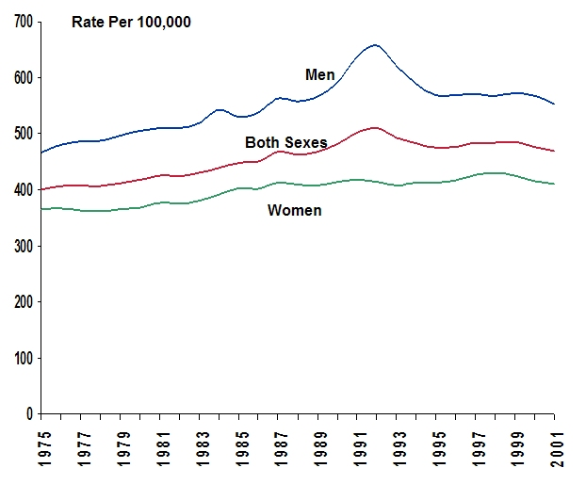

* Rates are age-adjusted to the 2000 US standard population.
Source: Incidence data from Surveillance, Epidemiology, and End Results (SEER) program, nine oldest registries, 1975 to 2001, Division of Cancer Control and Population Sciences, National Cancer Institute, 2004. Mortality data from US Mortality Public Use Data Tapes, 1960 to 2001, National Center for Health Statistics, Centers for Disease Control and Prevention, 2004.Error: Reference source not found
Figure 2: Cancer Prevalence: Estimated Number of Persons Alive in the US Diagnosed with Cancer by Site (N = 9.8 million)
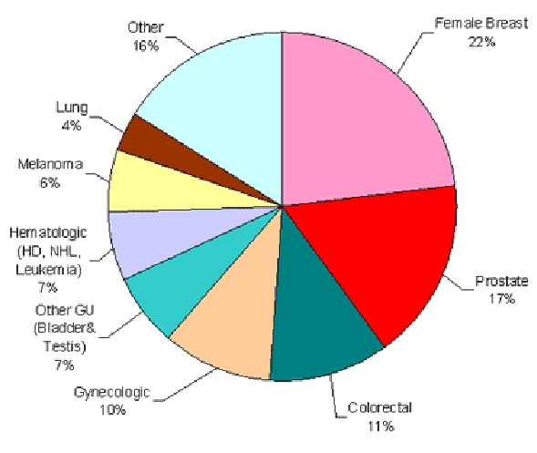

Source: November 2003 Submission: Populations from January 2001 were based on the average of the July 2000 and July 2001 population estimates from the US Bureau of Census. Complete prevalence is estimated using the completeness index method. US Estimated Prevalence counts were estimated by applying US populations to SEER 9 Limited Duration Prevalence proportions.

Figure 3: Cancer Prevalence: Estimated Number of Cancer Survivors in the US from 1971 - 2001
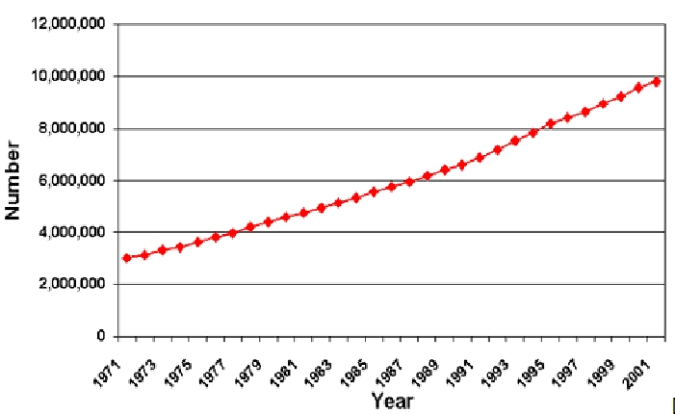

Source: November 2003 Submission: Populations from January 2001 were based on the average of the July 2000 and July 2001 population estimates from the US Bureau of Census. Complete prevalence is estimated using the completeness index method. US Estimated Prevalence counts were estimated by applying US populations to SEER 9 Limited Duration Prevalence proportions.Error: Reference source not found

Figure 4: Cancer Prevalence: Estimated Number of Persons Alive in the US Diagnosed with Cancer on January 1, 2001 by time
From Diagnosis and Gender (N = 9.8 million survivors).
Invasive / 1st Primary Cases Only
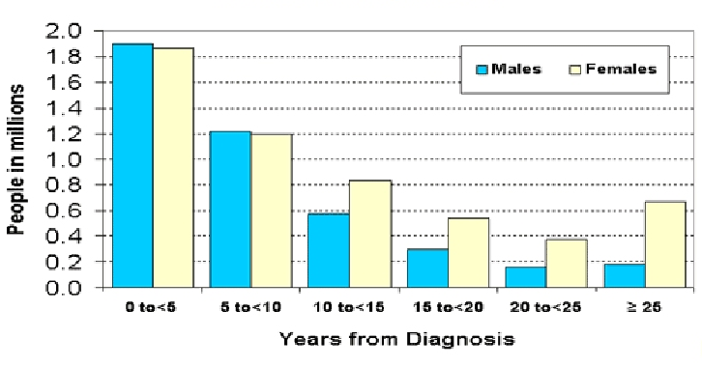

Source: November 2003 Submission: Populations from January 2001 were based on the average of the July 2000 and July 2001 population estimates from the US Bureau of Census. Complete prevalence is estimated using the completeness index method. US Estimated Prevalence counts were estimated by applying US populations to SEER 9 Limited Duration Prevalence proportions.Error: Reference source not found

Figure 5: Cancer Death Rates: Annual, Age-adjusted, for All Sites,
by Sex, US, 1975 – 2001*
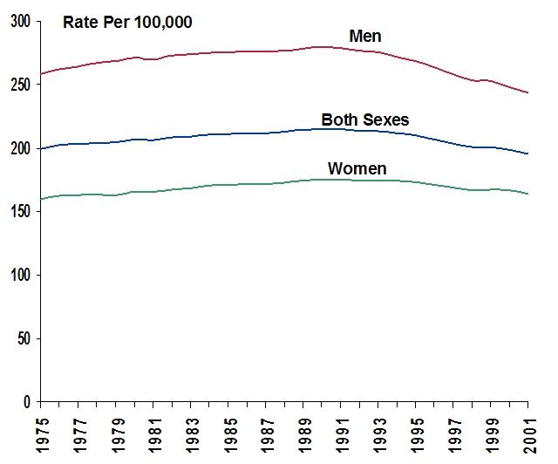

* Rates are age-adjusted to the 2000 US standard population.
Source: Incidence data from Surveillance, Epidemiology, and End Results (SEER) program, nine oldest registries, 1975 to 2001, Division of Cancer Control and Population Sciences, National Cancer Institute, 2004. Mortality data from US Mortality Public Use Data Tapes, 1960 to 2001, National Center for Health Statistics, Centers for Disease Control and Prevention, 2004.Error: Reference source not found
Figure 6: Cancer Mortality: Annual, Age-adjusted, Among Males
for Selected Cancer Types, US, 1930 – 2001*
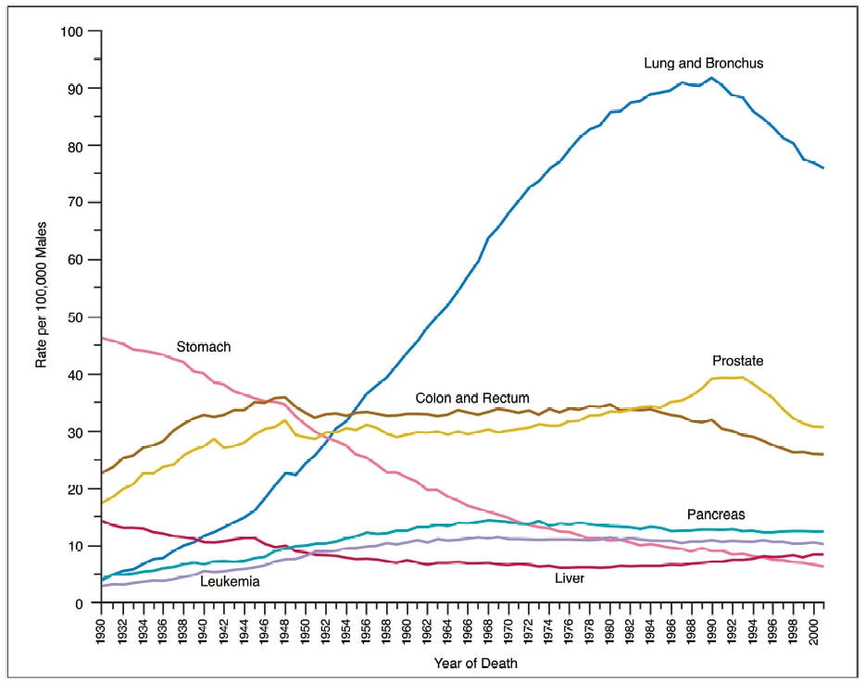

* Rates are age-adjusted to the 2000 US standard population.
Note: Due to changes in ICD coding, numerator information has changed over time. Rates for cancers of the lung and bronchus, colon and rectum, and liver are affected by these coding changes.
Source: Surveillance, Epidemiology, and End Results (SEER) program, nine oldest registries, 1975 to 2001, Division of Cancer Control and Population Sciences, National Cancer Institute, 2004.Error: Reference source not found

Figure 7: Cancer Mortality: Annual, Age-adjusted, Among Females for Selected Cancer Types, US, 1930 – 2001*
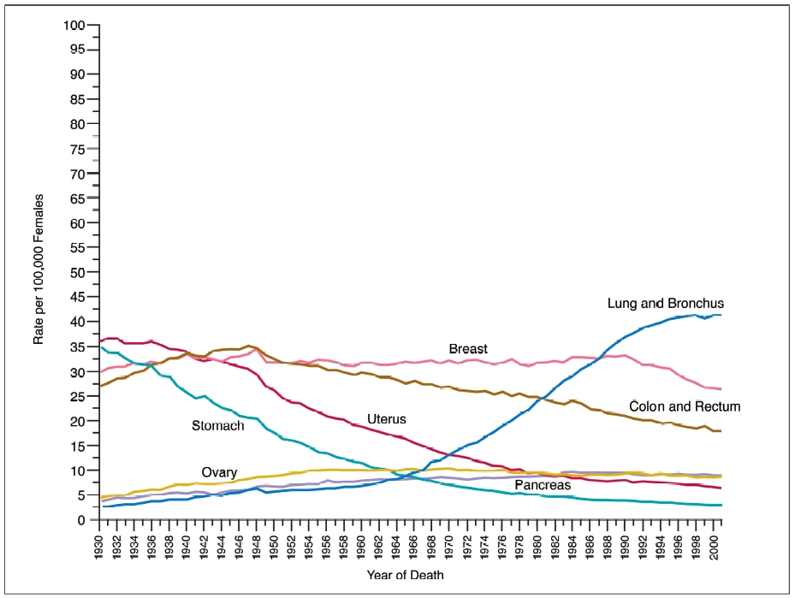

* Rates are age-adjusted to the 2000 US standard population.
Note: Due to changes in ICD coding, numerator information has changed over time. Rates for cancers of the uterus, ovary, lung and bronchus, and colon and rectum are affected by these coding changes. Uterus cancers are for uterine cervix and uterine corpus combined.
Source: Surveillance, Epidemiology, and End Results (SEER) program, nine oldest registries, 1975 to 2001, Division of Cancer Control and Population Sciences, National Cancer Institute, 2004.Error: Reference source not found

Suffering associated with cancer
Today, when people discover that they have cancer, their lives change dramatically. They have to learn to cope with both the disease and a wide range of issues that are frequently the manifestations of their illness experience (see Figure 9). ,,,,, Many symptoms, functional changes, wounds, psychological, social, spiritual, practical, end of life issues, and loss and grief affect their work and their family and often create predicaments that are difficult to adapt to.
While a disease affects an individual (the patient), the resulting illness also affects the patient’s family, ie, everyone close in knowledge, care and affection, and anyone who lives or works with the patient, or provides care.
As patients and families imagine their future with cancer, or the diagnosis of cancer in one of their children, fears and fantasies driven by past experiences and media dramatization frequently heighten anxiety about the events that may occur. Patients and families worry that symptoms won’t be managed, that they will lose function and control, and that they will be abandoned. They wonder who will provide care, how they will pay for it, what dying will be like, and what comes after death.,,

Family transitions
A diagnosis of cancer changes patients and families forever. As they move from a state of ‘wellness’ to a state of ‘illness with treatment,’ there may be a number of losses, including self-esteem, opportunity, income, financial security and the potential for a rewarding future (see Figure 8). The illness can interfere with experiences that bring meaning and value and add quality to their lives. It can cause suffering and lead everyone to question what the future holds in both life and death.
Cancer and its treatment often changes family roles and relationships. Leadership and group dynamics will be challenged and even changed. As an advanced life-threatening illness evolves and the patient dies, the existing family group adjourns and a new group forms that will have different membership, roles, leadership and group dynamics. While the patient is no longer present in person, her/his memories, and legacies live on and affect everyone.
Figure 8: Patient/family transitions during illness and bereavement
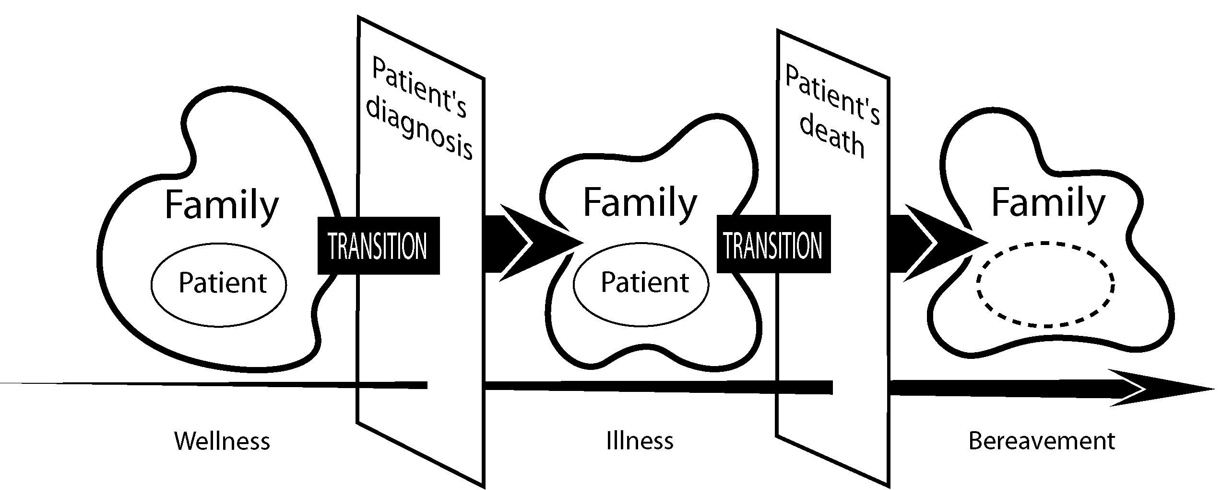
Figure 9: Domains & issues associated with illness and bereavement
Patients and families face multiple issues during illness and bereavement that cause suffering. These issues can be grouped into 8 domains.
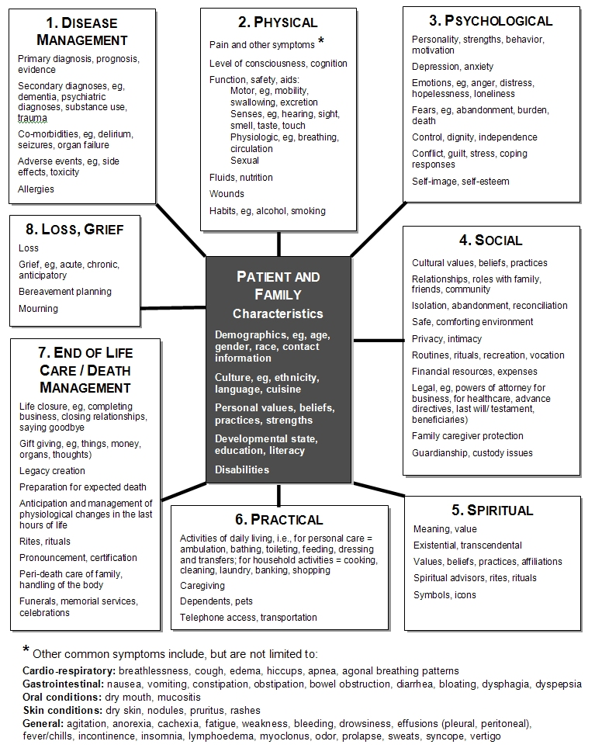

Symptoms and suffering
In one study of patients with cancer, inpatients averaged 13.5 symptoms while outpatients averaged 9.7 symptoms. While some of these symptoms are related to the primary illness, some are adverse effects of medications or therapy, and others result from intercurrent illness.

Psychological distress
In addition to physical symptoms, many patients and families also experience considerable psychological distress, including anxiety, depression, worry, fear, sadness, hopelessness, etc. In one study where many fears were expressed, 40% of patients with advanced illness where death was expected were afraid of being a burden to their family and friends.

Social isolation
Today, in contrast to our past, many Americans live alone, or only with one other adult. Often both need to work or, if they are older, at least one of them may be frail or ill. Other family members—brothers, sisters, children, and parents—often live far away and have ‘lives of their own.’ Friends have their own obligations and priorities. Although many Americans live in urban areas, there is considerable social isolation in this society that is built on independence and self-reliance.
While 90% of Americans believe it is a family’s responsibility to provide care for someone who is seriously ill, this social isolation creates a very different situation from the one that existed in the past. Today, when a patient needs assistance, the burden of caregiving frequently falls to a very small number of people, often women, who may be unskilled and without the resources they need to provide that care.

Financial pressures
In addition to the issue of who will provide care, financial issues associated with caregiving have a significant impact on the family. In one study, 20% of family members had to quit work or make another major life change in order to provide care for a loved one.Error: Reference source not found Even when they had medical insurance, a significant number of patients and families suffered financial devastation. In the same study, 31% of families lost most of their savings caring for their loved one; 40% of families became impoverished providing care. For some families, the financial implications may prohibit any thought of caring for a loved one at home.

Coping strategies
Particularly in the face of prolonged suffering and unmanaged symptoms, strategies for coping with illness, disability, loss of control, lack of ability to do things that are meaningful, etc. are varied. If suffering is not relieved, distress may be so significant that some patients may become destructive, planning suicide or seeking assistance to die prematurely by physician-assisted suicide or euthanasia.

Place of death
While a 1996 Gallup survey commissioned by the National Hospice Organization (NHO reported that 90% of the respondents desired to die at home, historically the technological development of medicine moved death out of the home and into institutions. People died, shielded from the family’s and community’s sight, usually behind hospital doors. By 1949, 50% of deaths in America occurred in institutions. As of 1958, this had increased to 61%. Since 1980 it has remained at around 74% (in 1992, 57% of Americans died in hospitals, 17% died in nursing homes, and only 20% died in their own homes).,
Given the strongly expressed desire to die at home, the pattern of death in the United States is paradoxical. Although there is some regional variation, the majority of patients dying in hospitals and nursing homes are dying with illnesses where the expected outcome is death. They could be managed at home. It is also clear that institutionalization does not yield better outcomes in terms of meeting patient and family needs.
As care for patients with life-threatening illnesses has shifted into institutions, a generalized lack of familiarity with the dying process and death has evolved. Only a minority of people, including physicians, have ever watched someone die. Most nonprofessionals have never seen a dead body except, perhaps, at a funeral parlor. Fantasy about what death is really like is fueled by media dramatization and rarely by reality.

Gaps
When the current status of care for the dying is summarized, the large gap between the way Americans currently live and die with cancer, and the way they would like to experience the end of their lives at home, becomes apparent. With the shift to fight death the enemy at all cost, treatments have frequently become excessively aggressive, symptoms have not been controlled, and patients have lost their independence. With the shift to care for very ill patients at home, many families have not coped, and death far too frequently has occurred in institutions. While generalizations may be misleading for individual patients and families, they do help to illustrate the general culture of dying in the United States and how far it is from the one that is desired by most Americans.

Public expectations of physicians
Despite their concerns, the public has an optimistic attitude toward end-of-life care and the role of their physician. In 1997, an AMA Public Opinion Survey asked, “Do you feel your doctor is open and able to help you discuss and plan for care in case of life-threatening illness?” The results showed that the majority of Americans (74%) expect their physician to be confident and competent to provide them with care when they do develop a life-threatening illness.

Palliative care
Palliative care aims to relieve suffering and improve the quality of life.
Initial concepts of hospice as end-of-life care developed from prolonged experience of illness and dying in cancer patients recognized by Dame Cicely Saunders in 1960s. The concept of palliative care has evolved from hospice over time. Today, the knowledge base and approaches to relieving suffering are too powerful and too important to save until the end of life. Now, there is no argument against integrating palliative care into cancer care from diagnosis to death.
Palliative care includes therapies to help patients and families manage the physical, psychological, social, spiritual and practical issues they face throughout their illness experience.Error: Reference source not found For oncologists and members of the cancer care team, palliative care also includes the important skills of communication and decision-making that help them facilitate the process of providing care.
Palliative care is appropriate for any patient and/or family living with, or at risk for developing cancer, with any prognosis, regardless of age, and at any time they have unmet expectations and/or needs, and are prepared to accept care. Palliative care may be combined with anticancer care or it may become the total focus of care. Palliative care is most effectively delivered by an interdisciplinary team of healthcare providers, ie, chaplains, nurses, occupational therapists, pharmacists, physicians, physiotherapists, social workers, speech therapists, volunteers, who are both knowledgeable and skilled in all aspects of the caring process related to their discipline of practice. In this definition, the terms supportive care, end-of-life care and bereavement care are part of this larger domain of palliative care (See Figure 10. It is less important that clinical services use the name ‘palliative care’ than that they reliably deliver the care that is needed.
Figure 10: Palliative Care
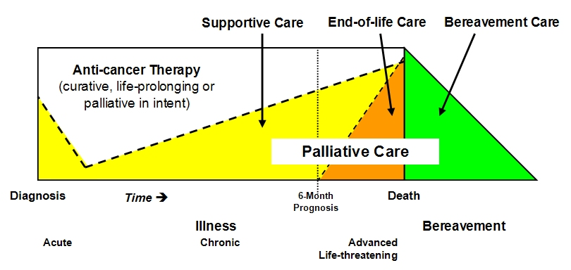
Focus of care

Notes about supportive care, eol care, bereavement care
This model of combining palliative care with standard cancer care is not just an assertion of this curriculum. It is included in reports from the leading oncology policy organizations. In 1999, the National Cancer Policy Board called for “the management of cancer-related pain and timely referral to palliative and hospice care” as part of its report entitled Ensuring Quality Cancer Care. This was followed in 2001 by a subsequent report entitled Improving Palliative Care for Cancer advocating that “cancer centers should play a central role … in advancing palliative care research and clinical practice…” (36). In support, the National Cancer Center Network has developed clinical practice guidelines for palliative care, distress, pain, practical and psychosocial issues, fatigue, delirium and depression.

Gaps in cancer care
The American Society for Clinical Oncology (ASCO) represents 19,000 physicians who practice medical, radiation, surgical, and pediatric oncology. In 1998, ASCO stated that it is the oncologists’ responsibility to care for their patient along a continuum that extends from the moment of diagnosis throughout the course of the illness. In addition to appropriate anticancer treatment, this includes symptom control and psychosocial support during all phases of care, including those during the last phase of life.

Oncologist training
In 1998, the American Society of Clinical Oncology conducted the first and only large-scale survey of US oncologists about their experiences in providing palliative care. The survey questionnaire consisted of 118 questions. A total of 3,227 oncologists responded. There were no significant differences between the percentages of medical, radiation, surgical, or pediatric oncologists who responded as a proportion of their representation in ASCO. The most frequent sources of palliative care education were
- 90% said they learned from trial and error during clinical practice
- 73% learned from colleagues during clinical practice
- 71% learned from a role model during oncology fellowship training.
- Interestingly, 38% said a significant source of education was a traumatic experience with a patient.
The evidence from the survey is that oncologists don’t get very good information from their colleagues and role models, despite reporting these people as the most frequent educational resource.
- 81% said they had inadequate mentoring or coaching in how to discuss poor prognosis.
- 65% said they received inadequate information about controlling symptoms.
- < 10% thought all of their formal training during medical school, internships, residency and fellowship combined was ‘very helpful’.
- Only 33% reported lectures about palliative care issues during oncology fellowship training.
- Only 10% reported a rotation on a palliative care service or hospice.

Barriers to palliative care
There are many other reasons why palliative care is not what it could or should be in oncology. A few that were illustrated by the ASCO survey are summarized here.
Sense of personal failure. In the ASCO survey, oncologists frequently report a sense of personal failure related to palliative and end-of-life care.
- 90% feel at least some anxiety discussing poor prognosis.
- 75% feel at least some anxiety discussing symptom control with patients and families.
- 76% report some sense of personal failure if a patient dies of cancer.
Unrealistic expectations. Oncologists also report that unrealistic expectations play a role in making the practice of oncology difficult.
- 29% felt it was unrealistic patient expectations.
- 50% felt family expectations made the work difficult.
- 27% reported that significant conflict arose from unrealistic expectations.
Pain management. Oncologists perceive that they don’t do a good job of pain management in their own practices. This is an important barrier because, if pain management isn’t good, there is little chance that the other aspects of palliative care will be incorporated into practice.
Burnout. > 50% of oncologists report the syndrome of burnout in their own personal lives. The syndrome of decreased energy, apathy, and imperviousness to needs of patients and their families prevents meeting those needs.
Other issues. In the ASCO survey, oncologists reported the following issues as having at least some influence on their practices related to palliative and end-of-life care.
- 97% percent felt oncologists were reluctant to ‘give up’.
- 99% felt that patient and/or family demands for antineoplastic therapy made it difficult.
- 80% felt that the reimbursement of chemotherapy, as opposed to other aspects of cancer care, influenced care.
- 80% felt that the reluctance to talk about issues other than antineoplastic therapy affected oncologist practice.
- 91% reported that the fact that it takes more time to do palliative care than give antineoplastic therapy influenced their practice.
Taken together, these reports help explain recent data indicating ineffective chemotherapy is administered nearly to the time of death in large numbers of cancer patients.
It is not the point of this plenary to analyze all of the determinants of the current state of affairs. There is enough blame to go around. However, if we are to build a health care system and ethic that cares or will care for all of us, then palliative care as part of comprehensive cancer care must improve.

Professional satisfaction
There is reason for hope. These bleak findings need to be contrasted with the sources of professional satisfaction these oncologists reported.
- 98% reported some emotional satisfaction to provide palliative care.
- 92% reported some intellectual satisfaction to provide palliative care.
Clearly, there is a marked contrast between the satisfaction that can be derived from the work, and the preparation for the work. It stands to reason that, if oncologists develop the core competencies and skills in palliative care, they and their patients and families will fare better.

Goals of EPEC-O
As one contribution to help bridge the gap between patient and family expectations and the current state of palliative care in comprehensive cancer care, the National Cancer Institute in collaboration with the American Society for Clinical Oncology and the EPEC Project team want to equip oncologists with the tools to teach a core base of knowledge and skills that, in their application, will help oncologists and their cancer programs improve their competence and confidence, strengthen physician-patient relationships, and enhance personal satisfaction with cancer care.

Topics
After providing an overview, EPEC-O presents strategies to help oncologists address the multiple issues that cause patients and families suffering and facilitate the process of providing comprehensive cancer care. It also offers strategies to further develop teaching skills. EPEC-O is not an attempt to make every oncologist an expert in palliative care.

Table 1: The topics within EPEC-O
Overview  Plenary 1: Gaps in Oncology  Plenary 2: Models of Comprehensive Care  Plenary 3: Charting the Future  Module 1: Comprehensive Assessment | Developing teaching skills  Teach 1: Teaching Skills 1  Teach 2: Teaching Skills 2
Addressing the multiple issues patients and families face  Module 2: Cancer Pain Management  Module 3: Symptoms, including Anorexia/cachexia, Anxiety, Ascites, Bowel Obstruction, Constipation, Delirium, Depression, Diarrhea, Dyspnea, Fatigue, Insomnia, Malignant Pleural Effusions, Menopausal Symptoms, Mucositis, Nausea/vomiting, and Skin  Module 4: Loss, Grief, and Bereavement  Module 5: Survivorship  Module 6: Last Hours of Living | The process of providing care  Module 7: Communicating Effectively  Module 8: Clarifying Diagnosis and Prognosis  Module 9: Negotiating Goals of Care  Module 10: Clinical Trials  Module 11: Withholding Nutrition, Hydration  Module 12: Conflict Resolution  Module 13: Advance Care Planning  Module 14: Physician-Assisted Suicide  Module 15: Cancer Doctors and Burnout  Teamwork: Approaches to sharing the burden of palliative care with colleagues through interdisciplinary teamwork is a theme throughout EPEC-O.

Once completed, in a manner analogous to the way that you learned during training, this knowledge needs to be applied in the environment in which you work to develop skill in its day-to-day application. In the end, we hope EPEC-O will equip oncologists to rediscover some of the core values of our profession and foster creative approaches to advocate for, and create, change in the myriad of situations and places in which oncologists serve patients with cancer and their families.
While physicians cannot change everything, change will not be very effective without them. Physicians have a special responsibility and leadership opportunity in palliative care.

Summary
The diagnosis of cancer affects every person. Comprehensive cancer care COMBINES effective and appropriate anti-cancer care with palliative care to manage both the cause and the experience. Oncologists are not yet sufficiently trained to be competent or confident in to provide palliative care. The EPEC-O curriculum will equip physicians with knowledge, skills, and attitudes that can be tailored to their unique practice settings. The ultimate goal: to relieve suffering and improve the quality of the lives of all Americans who are living with, or dying from, cancer. If appropriately applied, palliative care has the potential to enhance cancer care and improve outcomes.

Key take-home points
- More than 500,000 Americans each year will not be cured of their cancer.
- Palliative care aims to relieve suffering and improve the quality of life. It can be combined with antineoplastic therapy or be the focus of care.
- Several studies indicate that most patients and families who are living with cancer can expect to experience multiple physical symptoms along with psychological, social, spiritual, and practical issues. While some of these symptoms are related to the primary illness, some are adverse effects of medications or therapy, and others result from intercurrent illness.
- Ninety percent of the respondents to a Gallup survey in 1996 desire to die at home, yet nearly 80% currently die in institutions.
- The majority of Americans (74%) expect their physician to be confident and competent to provide them with care when they do develop a life-threatening illness.
- Many oncologists believe they have failed and experience a sense of shame if they do not save their patients from death.
- Hospice care is introduced too late. When the median length of stay is less than 30 days, patients and families don’t realize the full potential that hospice offers.
- Until recently, formal education in end-of-life care has been absent from medical school, residency, and fellowship training.

Approaching Death: Improving Care at the End of Life—a Report of the Institute of Medicine. Washington, DC: National Academy Press; 1997. ISBN: 0309063728. PMID: 12693886. Seminal and influential report describing health care needs of patients with terminal illness in the US.
Nixon R. The war against cancer. Prog Clin Biol Res. 1987;248:3-8. PMID: 3671418. President Nixon hoped the declaration of ‘war on cancer’ in 1971 would be the most significant action taken by his administration.
Bailar JC, Gornik HL. Cancer undefeated. N Engl J Med. 1997;336(22):1569-1574. PMID: 9164814. National Center for Health Statistics data on all deaths from cancer for 1970 through 1994. Age-adjusted mortality for cancer in 1994 was 6% higher in 1994 than in 1970. Death rates from specific cancers have declined due to reduced cigarette smoking, improved screening and a mixture of increases and decreases in the incidence of cancer.
Welch HG, Schwartz LM, Woloshin S. Are increasing 5-year survival rates evidence of success against cancer? JAMA. 2000;283(22):2975-2978. http://gateway.ut.ovid.com/gw2/ovidweb.cgi Accessed March 28, 2005. Population-based statistics reported by the National Cancer Institute Surveillance, Epidemiology and End Results (SEER) Program. From 1950-1995 there was an increase in 5-year survival for each of 20 tumor types (range 3% pancreatic to 50% prostate). During the same period, mortality rates declined for 12types of cancer and increased for the remaining 8 types. Changes in 5-year survival did not correlate with mortality data, but did correlate with incidence data.
Jemal A, Murray T, Ward E, Samuels A, Tiwari RC, Ghafoor A, Feuer EJ, Thun MJ. Cancer statistics, 2005. CA Cancer J Clin. 2005;55(1):10-30. PMID 15661684. Full Text A summary of the most recent data on cancer incidence, mortality and survival using incidence data from the National Cancer Institute and mortality data from the National Center for Health Statistics.
Kochanek KD, Murphy SL, Anderson RN, Scott C. Deaths: final data for 2002. Natl Vital Stats Rep. October 12, 2004;53(5):1-115. PMID: 15587328. Available at http://www.cdc.gov/nchs/fastats/deaths.htm. Accessed February 19, 2005.
Estimated US Cancer Prevalence. Washington, DC: National Cancer Institute; 2005. Available at http://cancercontrol.cancer.gov/ocs/prevalence/prevalence.html. Accessed February 19, 2005.
Emanuel LL, Alpert HR, Baldwin DC, Emanuel EJ. What terminally ill patients care about: toward a validated construct of patients’ perspectives. J Palliative Med. 2000;4(3):419-431.
Emanuel EJ, Emanuel LL. The promise of a good death. The Lancet. 1998;351:21-29. PMID 9606363.
Gerteis M, Edgmam-Levitan S, Daley J, Delbanco TL, eds. Through the Patient's Eyes: Understanding and Promoting Patient-centered Care. San Francisco: Jossy−Bass Publishers; 1993.
Singer PA, Martin DK, Kelner M. Quality end-of-life care: patients’ perspectives. JAMA. 1999;281(2):163-168. PMID 9917120.
Steinhauser KE, Clipp EC, McNeilly M, Christakis NA, McIntyre LM, Tulsky JA. In search of a good death: observations of patients, families and providers. Ann Intern Med.. 2000;132(10):825-832. PMID 10819707.
Steinhauser KE, Christakis NA, Clipp EC, McNeilly M, Grambow S, Parker J, Tulsky JA. Preparing for the end of life: preferences of patients, families, physicians, and other care providers. J Pain Symptom Manage. 2001;22(3):727-737. PMID 11532586.
Steinhauser KE, Christakis NA, Clipp EC, NcNeilly M, McIntyre L, Tulsky JA. Factors considered important at the end of life by patients, family, physicians and other care providers. JAMA. 2000;284(19):2476-2482. PMID: 11074777. Cross-sectional random national survey of 340 seriously ill patients, 332 recently bereaved family and 361 physicians asked to rate importance of 44 items. Freedom from pain was most important. Items ranked important by all groups: pain and symptom control, preparation for death, achieving a sense of completion, decisions about treatment preferences and being treated as a ‘whole person’. Items ranked more important by patients than physicians: being mentally aware, having funeral arrangements planned, not being a burden, helping others and coming to peace with God. Dying at home was the least important.
Emanuel EJ, Fairclough DL, Slutsman J, Emanuel LL. Understanding economic and other burdens of terminal illness: the experience of patients and their caregivers. Ann Intern Med. 2000;132:451-459. PMID: 10733444. Full Text Structured interviews of representative sample of 988 terminally ill patients (prognosis < 6 months by their physician) at home in 5 US cities. 51.8% with cancer. 59% over age 65, 51% women. Symptom prevalence: pain: 50% moderate to severe), ECOG Score > 3: 18% Dyspnea 71%, Incontinence 36%. Regarding pain control. 29% wanted more therapy, 34% feared addiction, 31% were concerned with side effects (e.g. constipation). 35% report subjective sense of economic burden. Of those with substantial care needs (34.7%), economic burden, percent of household income spent on health care, needing a loan, spending their savings, needing an additional job were higher. Family caregivers were more likely to have depressive symptoms. Caregivers of patients whose physicians listened to patients’ and caregivers’ needs were less likely to be depressed (28%) as those who didn’t (42%).
Emanuel EJ, Fairclough DL, Slutsman J, Alpert H. Baldwin D, Emanuel LL. Assistance from family members, friends, paid caregivers and volunteers in the care of terminally ill patients. N Engl J Med. 1999;341(13):956-963. PMID: 10498492. Structured interviews of representative sample of 988 terminally ill patients (prognosis < 6 months by their physician) at home in 5 US cities. 51.8% with cancer. 59% over age 65, 51% women. 86.8% reported need for assistance. 62% needed help with transportation, 55.2% homemaking, 28.7% nursing care, 26% personal care. 96% of carers were family members (72% women). Only 15.5% used paid assistance. Volunteers provided less than 3% of care.
Portenoy RK, Thaler HT, Kornblith AB, et al. Symptom prevalence, characteristics and distress in a cancer population. Qual Life Res. 1994;3(3):183-189. PMID: 7920492. Systematic assessment of prevalence eand characteristics of symptoms in 243 patients at Memorial Sloan-Kettering. Mean age 55.5 (range 23-86). 123 were inpatients. 40-80% experienced lack of energy, pain, feeling drowsy, dry mouth, insomnia or symptoms of psychological distress. The mean number of symptoms per patients was 11.5 + 6.0; inpatients had more symptoms than outpatients (13.5 vs 9.7) and those with Karnofsky performance score < 80 had more symptoms than those with a higher score (14.8 vs 9.2).
A controlled trial to improve care for seriously ill hospitalized patients: the study to understand prognoses and preferences for outcomes and risks of treatments (SUPPORT). The SUPPORT Principal Investigators. JAMA. 1995;274(20):1591-1598. PMID: 7474243. A 4-year prospective study of 9,105 patients with a 47% 6-month mortality rate in 5 teaching hospitals testing a shared decision-making model to improve outcomes. The intervention failed to improve care or patient outcomes such as patient-physician communication or level of reported pain. This seminal study was trigger for intense research into how to improve palliative care.
The Gallup Organization. Knowledge and Attitudes Related to Hospice Care. Survey conducted for the National Hospice Organization. Princeton, NJ: The Gallup Organization; September 1996.
Facts on dying: policy relevant data on care at the end of life. Available at http://www.chcr.brown.edu/dying/FACTSONDYING.HTM. Accessed March 27, 2005.
Care at the end of life. In: The Dartmouth Atlas of Health Care. Available at http://www.dartmouthatlas.org/endoflife/end_of_life.php. Accessed March 27, 2005.
Tang ST, McCorkle R. Determinants of place of death for terminal cancer patients. Cancer Invest. 2001;19(2):165-180. PMID: 11296621. 70% of cancer patients prefer to die in their own homes from studies outside the US (range 53-89%). In studies including the US, only 20% do die at home. In studies of patients enrolled in hospice programs, 60% die at home.
Teno JM, Clarridge BR, Casey V, Welch LC, Wetle T, Shield R, Mor V. Family perspectives on end-of-life care at the last place of care. JAMA. 2004;291:88-93. PMID: 14709580. Mortality follow-back survey of family members representing 1578 decedents representing 1.97 million deaths in the US. 67% of patients died in an institution. About ¼ of all decedents with pain or dyspnea did not receive adequate treatment and about ¼ reported physician communication concerns. Family members of patients receiving hospice services were more satisfied with overall quality of care.
Diem SJ, Lantos JD, Tulsky JA. Cardiopulmonary resuscitation on television. Miracles and misinformation. N Engl J Med. 1996:334(24):1578-1582. PMID: 8628340. Three popular television programs (Chicago Hope, ER, Rescue 911) were observed for depictions of CPR in the 1994-95 season. Short term survival was 64% (Chicago Hope), 68% (ER) and 100% (Rescue 911). Implied survival to discharge was 36% (Chicago Hope), 58% (ER) and 100% (Rescue 911).
American Medical Association. Public Opinion on Health Care Issues: 1997. Chicago, IL: American Medical Association; August 1997.
World Health Organization. Definition of Palliative Care http://www.who.int/cancer/palliative/definition/en/ (accessed December 14, 2004) Palliative care is an approach that improves the quality of life of patients and their families facing the problem associated with life-threatening illness, through the prevention and relief of suffering by means of early identification and impeccable assessment and treatment of pain and other problems, physical, psychosocial and spiritual.
Saunders C. The evolution of palliative care. J R Soc Med. 2001;94(9):430-432. PMID: 11535742. Full Text
Foley KM, Gelband H, eds. Improving Palliative Care for Cancer. National Cancer Policy Board, Institute of Medicine, National Research Council. Washington, DC: National Academy Press; 2001. ISBN: 0309074029. Builds on 1997 report of the Institute of Medicine. Makes 10 recommendations to the Congress and the National Cancer Institute to improve palliative care for cancer.
Ferris F, Balfour H, Bowen K, Farley J, Hardwick M, Lamontagne C, Lundy M, Syme A, West P. A model to guide patient and family care. Based on nationally accepted principles and norms of practice. J Pain Symptom Manage. 2002;24(2):106-123. PMID: 12231127. Model for palliative care based on a national consensus process in Canada. The full model is available at http://www.chpca.net/publications/norms_of_practice.htm. Accessed February 19, 2005.
American Society of Clinical Oncology. Cancer care during the last phase of life. J Clin Oncol. 1998;16(5):1986-1996. PMID: 9586919. Consensus view of role of palliative care in comprehensive cancer care and the role of the oncologist.
Hilden JM, Emanuel EJ, Fairclough DL, Link MP, Foley KM, Clarridge BC, Schnipper LE, Mayer RJ. Attitudes and practices among pediatric oncologists regarding end-of-life care; results of the 1998 American Society of Clinical Oncology survey. J Clin Oncol. 2001;19(1):205-212. PMID: 11134214. Full Text All members of ASCO in the US, Canada and the United Kingdom received a 118 question survey covering eight categories. Predictors of particular attitudes and practices were identified using stepwise logistic regression analysis. Pediatric oncologistists reported a lack of formal courses, a strikingly high reliance on trial and error and a need for strong role models.
Von Roenn JH, Cleeland CS, Gonin R, Hatfield AK, Pandya KJ. Physician attitudes and practice in cancer pain management. A survey from the Eastern Cooperative Oncology Group. Ann Intern Med. 1993;119(2):121-126. PMID: 8099769. Full Text A survey of the Eastern Cooperative Oncology Group (ECOG) was completed by 897 of 1800 surveys sent. 86% of those responding thought the majority of patients with pain were undermedicated. Only 51% believed pain control in their own practice setting was good or very good. 31% would wait until the patient’s prognosis was 6 months or less before they would start maximal analgesia. Poor pain assessment was rated by 76% of physicians as the single most important barrier. 62% reported patient reluctance to take analgesics as well as physician reluctance to prescribe opioids were significant barriers.
Whippen DA, Canellos GP. Burnout syndrome in the practice of oncology; results of a random survey of 1,000 oncologists. J Clin Oncol. 1991;9(10):1916-1920. PMID: 1919641. 598/1000 (60%) of physicians returned a 12-point questionnaire mailed randomly selected physician subscribers to the Journal of Clinical Oncology. 56% reported experiencing burnout in their professional life. Frustration or a sense of failure was the most frequently chosen (56%) description. Administering palliative or terminal care, reimbursement issues and a heavy work load were identified as contributing factors.
Emanuel EJ, Young-Xu Y, Levinsky, NG, Gazelle G, Saynina O. Chemotherapy use among Medicare beneficiaries at the end of life. Ann Intern Med. 2003;138(8):639-643. PMID: 12693886 . Full Text This article discusses the frequency and duration of chemotherapy use in the last 6 months of life stratified by type of cancer, age, and sex using a retrospective cohort analysis.

